1000 PIECES PUZZLE Portugal
DANCE CAREER BOOTCAMP FOR EMERGING ARTISTS
- Application Form -

EN. You can answer in English or Portuguese

- Personal

PERSONAL DATA

Name: Surname: __________________________

Date of birth: Gender: male female

Nationality: _______________

2) Dance experience & motivation

Which dance styles best describe your practice?

Dancehall Afrobeats Hiphop House Krump

Waacking Contemporary African & Caribbean dances Others:

Tell us more about your dance and choreographic experience so far e.g.: training, teaching, performances, battles, awards, championships….

Please answer in max. 800 words or a 2min. video (paste a link here)

________________________________________________________________________________________________________________________________________________________________________________________________________________________________________________________________________________________________________________________________________________________________________________________________________________________________________________________________________________________________________________________________________________________________________________________________________________________________________________________________________________________________________________________________________________________________________________________________________________________________________________________________________________________________________________________________________________________________________________________________________________________________________________________________________________________________________________________________________________________________________________________________________________________________________________________________________
________________________________________________________________________
________________________________________________________________________
________________________________________________________________________
________________________________________________________________________
________________________________________________________________________
What do you want to get out of the programme?

Please answer in max. 800 words or a 2min. video (paste a link here)

________________________________________________________________________________________________________________________________________________________________________________________________________________________________________________________________________________________________________________________________________________________________________________________________________________________________________________________________________________________________________________________________________________________________________________________________________________________________________________________________________________________________________________________________________________________________________________________________________________________________________________________________________________________________________________________________________________________________________________________________________________________________________________________________________________________________________________________________________________________________________________________________________________________________________________________________________________________________________________________________________________

How do you see yourself contributing to the dance scene in the future?

Please answer in max. 800 words or a 2min. video (paste a link here)

________________________________________________________________________________________________________________________________________________________________________________________________________________________________________________________________________________________________________________________________________________________________________________________________________________________________________________________________________________________________________________________________________________________________________________________________________________________________________________________________________________________________________________________________________________________________________________________________________________________________________________________________________________________________________________________________________________________________________________________________________________________________________________________________________________________________________________________________________________________________________________________________________________________________________________________________________________________________________________________________________________

3) Video

Mobile phone quality is OK, Between 1 à 3 minutes long
This can be freestyle or a piece of choreography. Please note that we need to see your skills clearly, therefore please a steady shot and unedited video is preferred over an overload of funky, quick edits.

URL (Youtube, Vimeo,…)__________________________________________________

Practical

Please be aware that majority of the programme will be delivered in English. Please rate your language skills below.

How would you rate your
Very Poor Poor Average Good Very Good
- English understanding
2. English speaking

Please confirm you can attend the full week, dates 16/04/2018-21/04/2019: yes I can

Email: ___________________________ Phone: ________________________

Address: Address Line 1 ______________________________________
Address Line 2 ______________________________________
City _____________________ State / province / region ______________
Postal/Zip Code ___________ country ___________________________

Would you like to stay at one of our studios? yes no

we offer to camp in one of our studios (for Portuguese dancers only, upon reservation, own camping equipment required and basic facilities)

Are you on social media, please note your profiles (Facebook,Instagram,Linkedin, Vimeo, Youtube,…)

Do you have a website? If yes: ___________________________

How did you hear of 1000 PP Bootcamp Portugal?
facebook coffeepaste.pt others:

I’m done!

Please send us a copy or paste directly into the e-mail: info@performact.org for your application. We will come back to you after the new DEADLINE 31.01.2019 - @ 12:00 noon

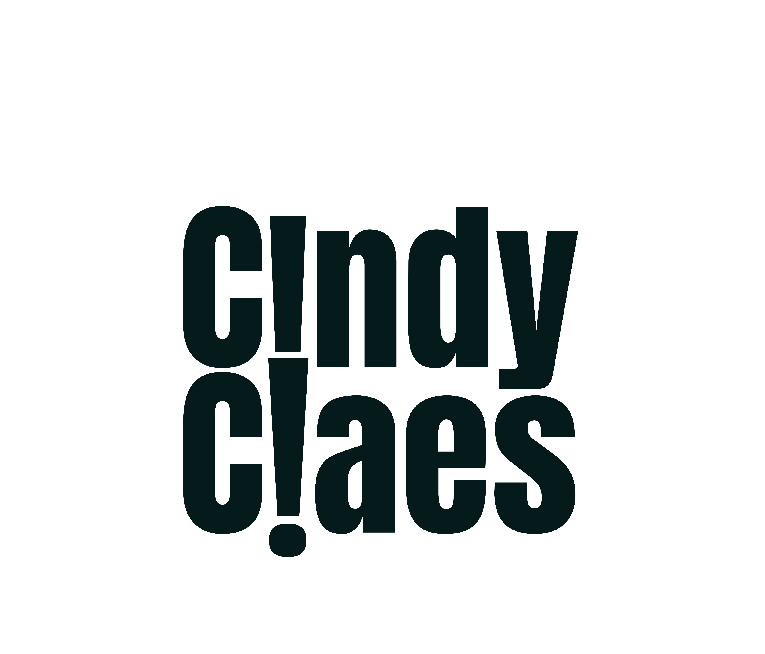
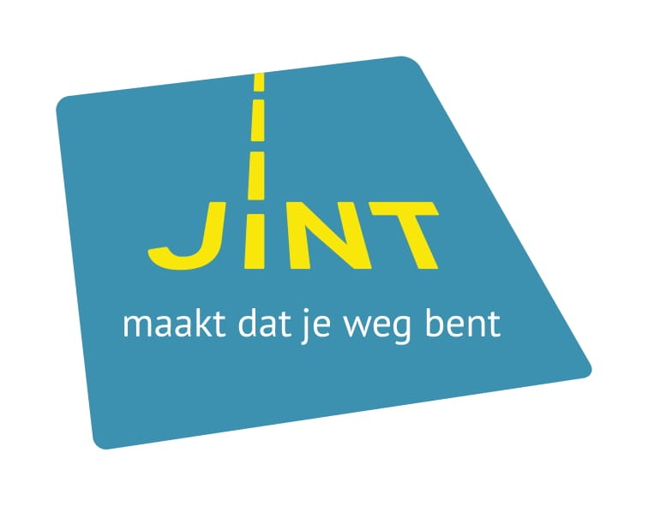
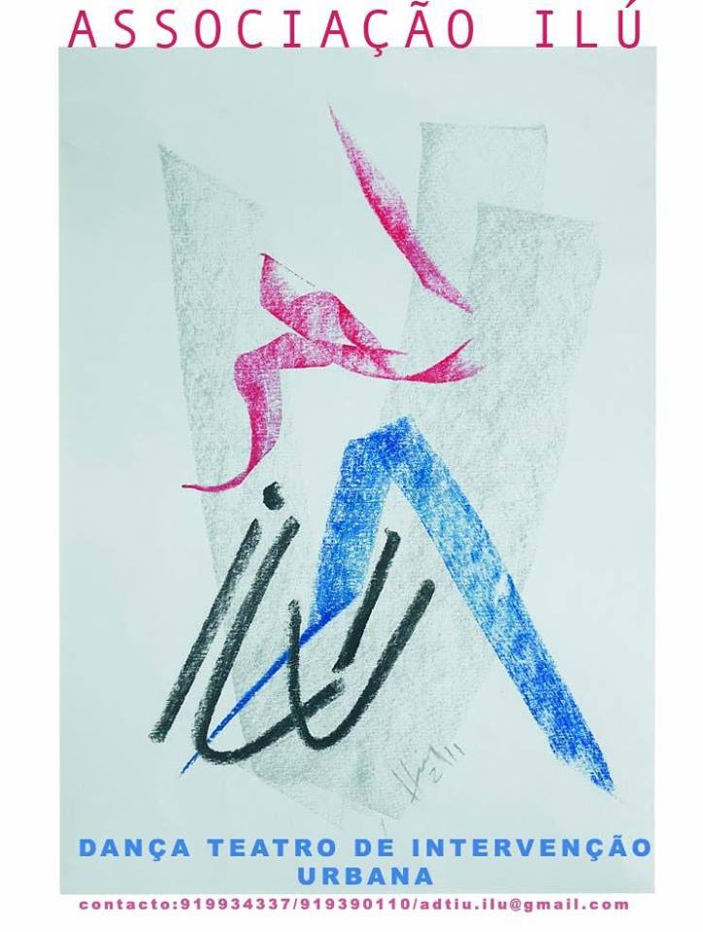
Date: ____________ Signature: ___________________________

